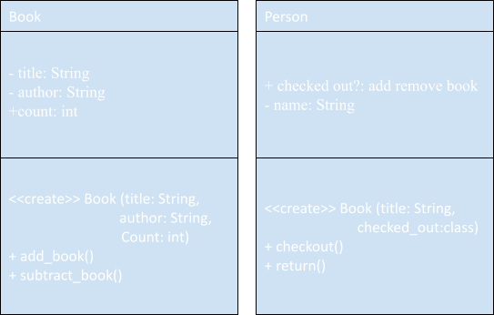

Boolean not needed, as long as the count is above or below 0 we can use that as a true or false for availability.

